Homework 4
Create your own function in C that accepts one input parameter and returns a float number. You decide the theme.
You should provide both your C code and an example call to the C code function. Be sure to provide an overview of what your function is doing.
The code I have prepared calculates the perimeter of a square.
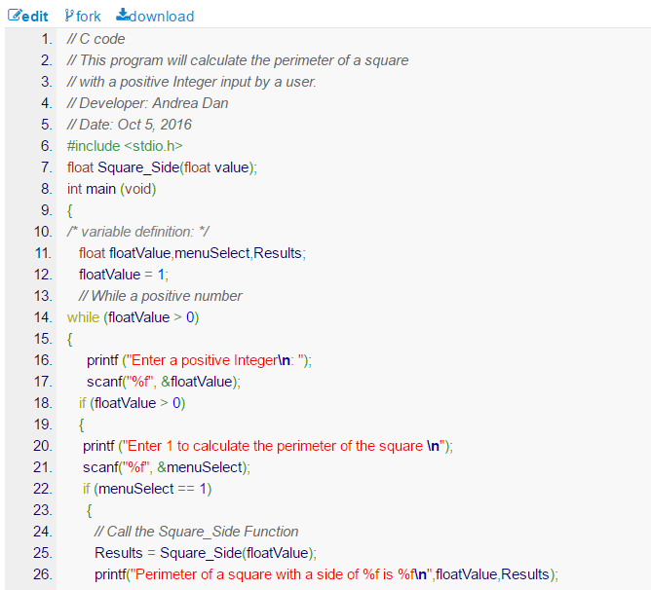
Provide a screen capture showing the results of testing your code in an online compiler.
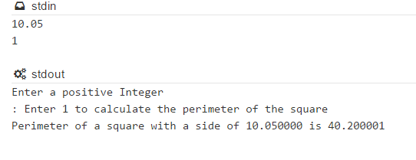
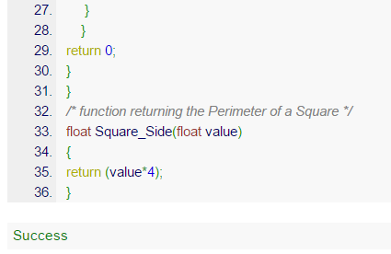
Be sure to test your code with several test cases and show your test case table.

Test # | Input | Expected Output
1 | 0.359  1 | Enter a positive Integer  : Enter 1 to calculate the perimeter of the square  Perimeter of a square with a side of 0.359000 is 1.436000
2 | 199  1 | Enter a positive Integer  : Enter 1 to calculate the perimeter of the square  Perimeter of a square with a side of 199.000000 is 796.000000
3 | -2.78  1 | Enter a positive Integer  :

Test 1
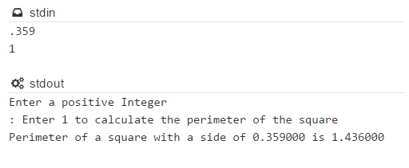
Test 2
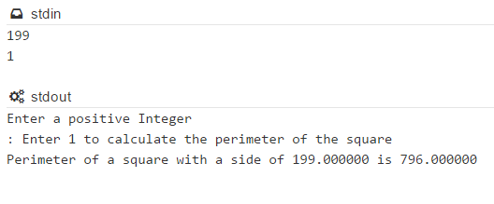
Test 3
